**Architectural Analysis**

**CELLA 150**

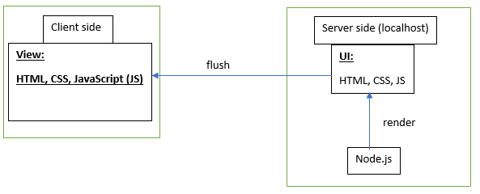

It is a type of Web handling which uses a Single Threaded Event Loop Model. It differs from other technologies like HTML, JSP etc. which use a Multi-Threaded Model. NodeJS maintains a list to provide services to Client Requests.

This approach result in avoiding CPU switching tasks and stacking of memory.